**Indian Restaurant Business - Near Hartford**

**Introduction:**

A global restaurant company is planning to expand its business in eastern part of the United states of America. Key cities in the western part of US are New York and Hartford. As New York requires more capital expenditure, company is planning to focus on opening business in Hartford first.

Primarily, company wants to determine right location for the new Indian restaurant around Hartford vicinity based on existing restaurant details.

**Data Elements:**

In order to understand current Indian restaurant business in the Connecticut, Foursquare API will be used wherein FOURSQUARE API will be list all the restaurants and provide their location details. Refer to county details to get all restaurant details from <https://www.connecticut-demographics.com/cities_by_population>

**Key tasks**

1. Prepare the map of restaurant availability which will help in decision making.
2. Analyze the data and provide your recommendation.
3. Use population data using <https://www.connecticut-demographics.com/cities_by_population>

as well to determine ration of restaurant per capita which will also be a key factor in the decision.

Key data fields:

Restaurant name

Restaurant address

Restaurant latitude

Restaurant Longitude

Township name

Township Population

Ration (Population/restaurants)

**Final Report**

Below image illustrates location where Indian restaurants are already present. Area around Hartford, New London, Bridgeport and New Heaven are the key area where higher number of Indian restaurants are available which signifies that they are good area for the restaurant business.

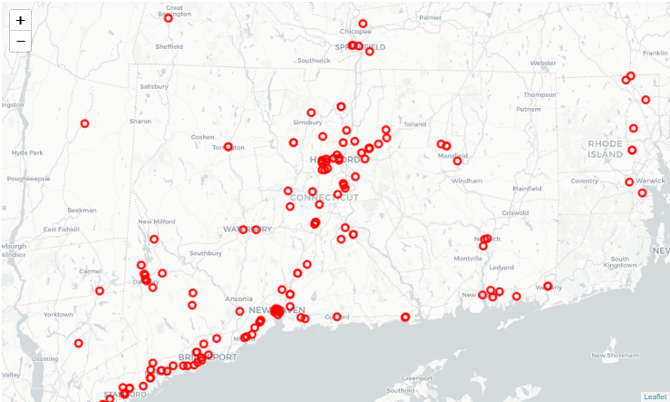

However, on the flip size company can think of area where India restaurants are not present at all. Following cities have high population with zero restaurants.

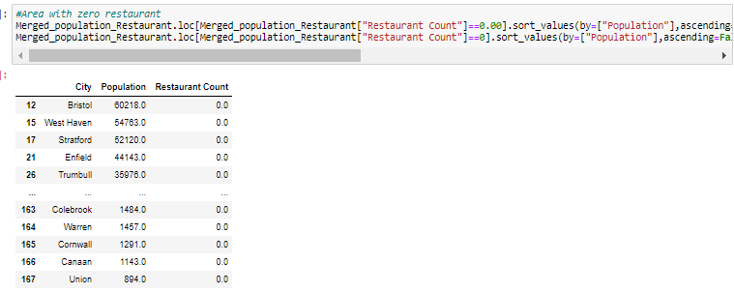

|  |  |  |
| --- | --- | --- |
| **City** | **Population** | **Restaurant Count** |
| Bristol | 60218 | 0 |
| West Haven | 54763 | 0 |
| Stratford | 52120 | 0 |
| Enfield | 44143 | 0 |
| Trumbull | 35976 | 0 |
| Naugatuck | 31347 | 0 |
| Newington | 30234 | 0 |
| Cheshire | 29147 | 0 |
| East Haven | 28742 | 0 |
| Mansfield | 25799 | 0 |
| Farmington | 25528 | 0 |
| Ridgefield | 25042 | 0 |
| Windham | 24655 | 0 |
| Watertown | 21751 | 0 |
| New Canaan | 20276 | 0 |
| Southbury | 19681 | 0 |
| Waterford | 18935 | 0 |
| Montville | 18835 | 0 |

One more way to look at current situation is ration of population in the city vs number of Indian restaurants in the city. Following is the area with such a high ration and company can consider expanding such areas for new business.

